**PROJECT REVIEW – 2 (INTEGRATED JS)**

Topic:- **Geometric Shapes and its applications**

Name: Tithi Shah

Reg. No.: 23BCE0809

1. Added dark mode toggle button using js into HOME PAGE

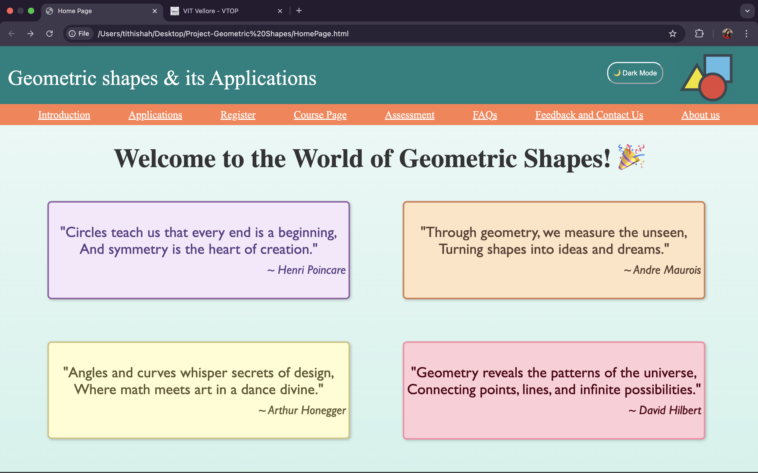

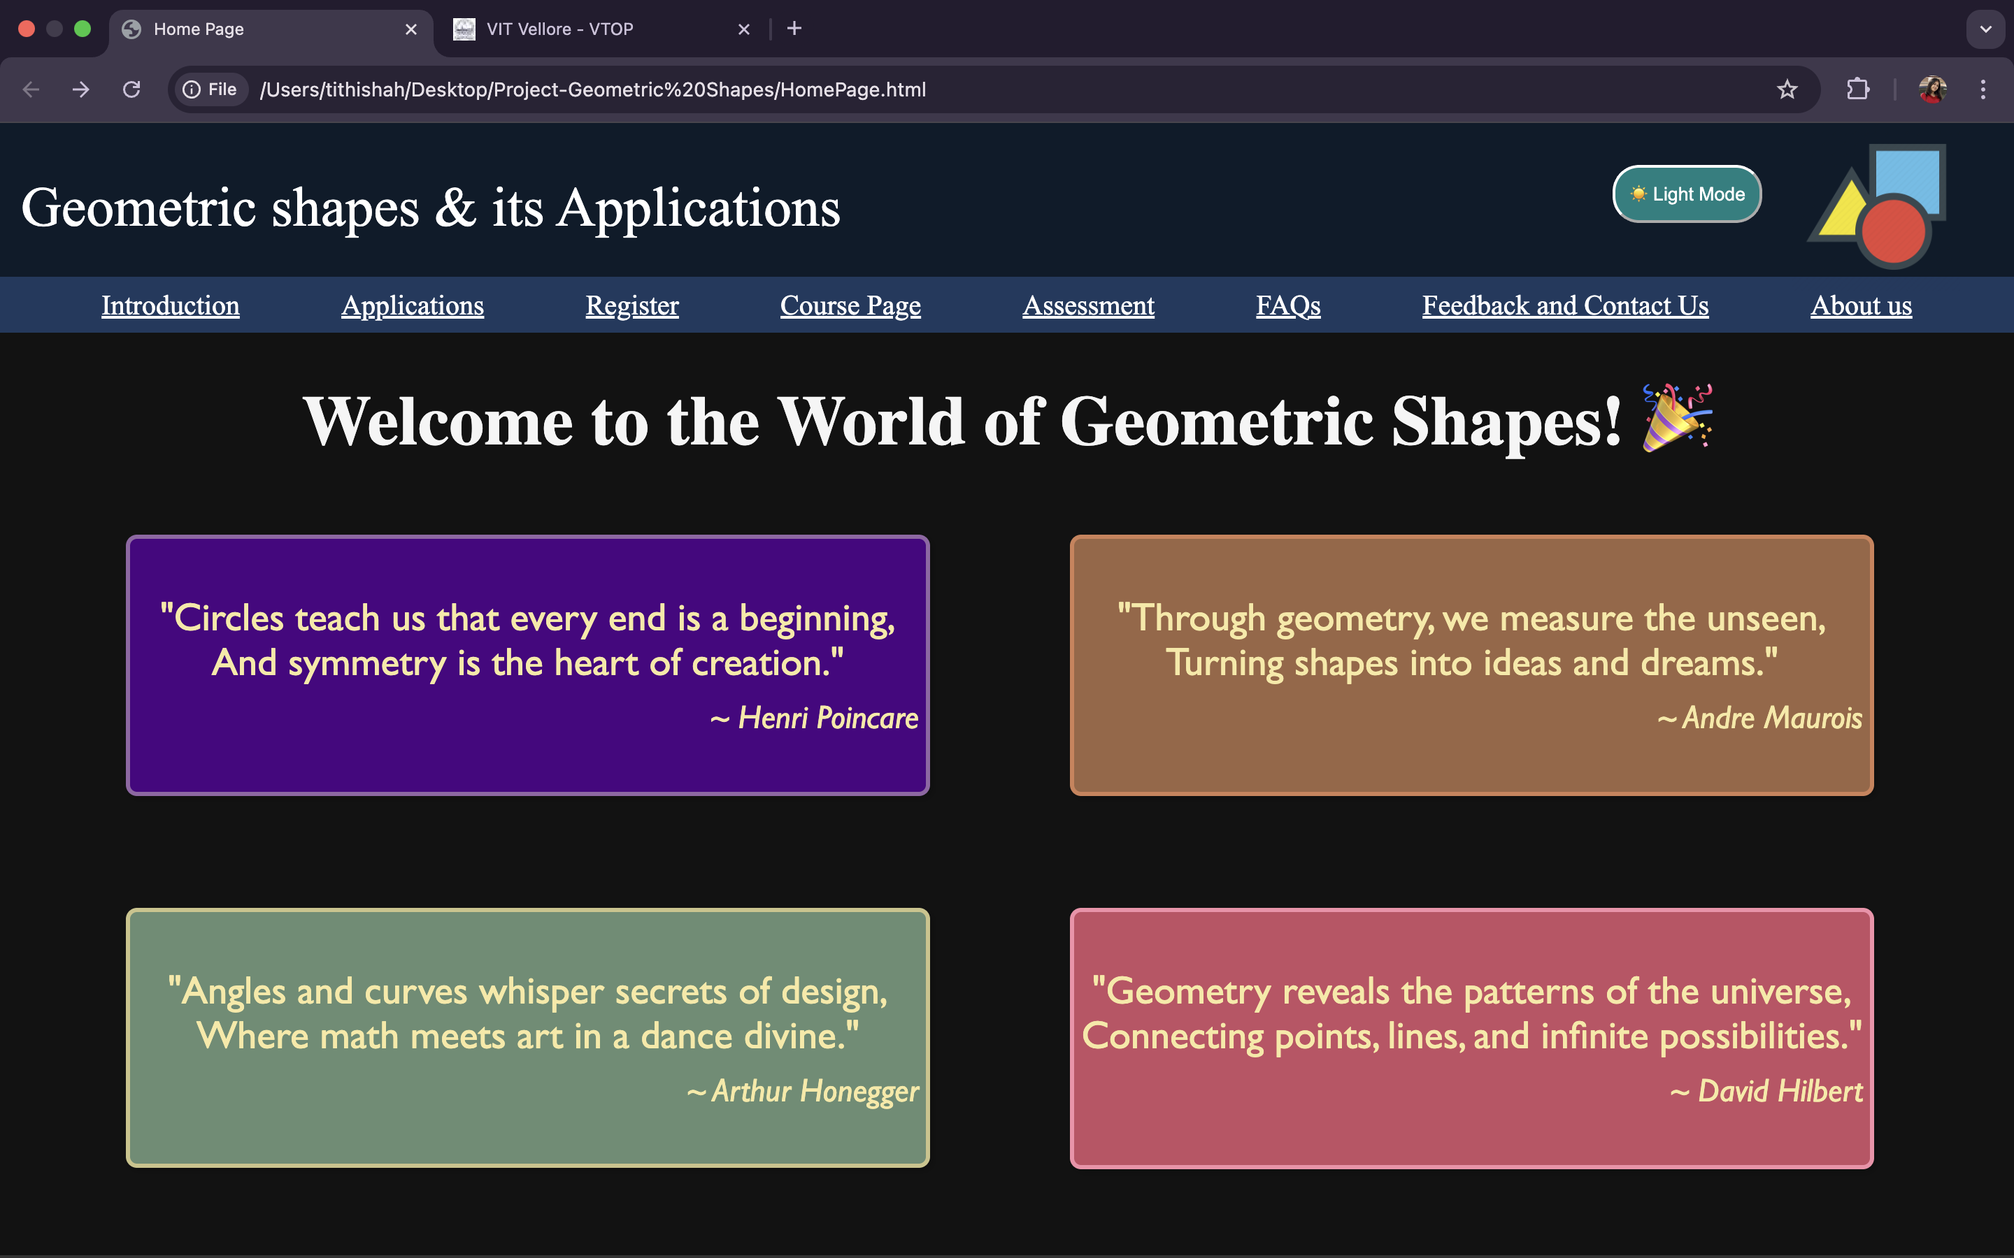

Js Code:

const toggleButton = document.createElement("button");

toggleButton.textContent = "🌙 Dark Mode";

toggleButton.style.position = "fixed";

toggleButton.style.top = "30px";

toggleButton.style.right = "180px";

toggleButton.style.padding = "10px";

toggleButton.style.cursor = "pointer";

toggleButton.style.color="white";

toggleButton.style.borderRadius="19px";

toggleButton.style.borderColor="white";

toggleButton.style.backgroundColor="#008080";

document.body.appendChild(toggleButton);

toggleButton.addEventListener("click", () => {

document.body.classList.toggle("dark-mode");

toggleButton.textContent = document.body.classList.contains("dark-mode") ? "☀️ Light Mode" : "🌙 Dark Mode";

});

1. Sign Up page – FORM VALIDATION   
     
   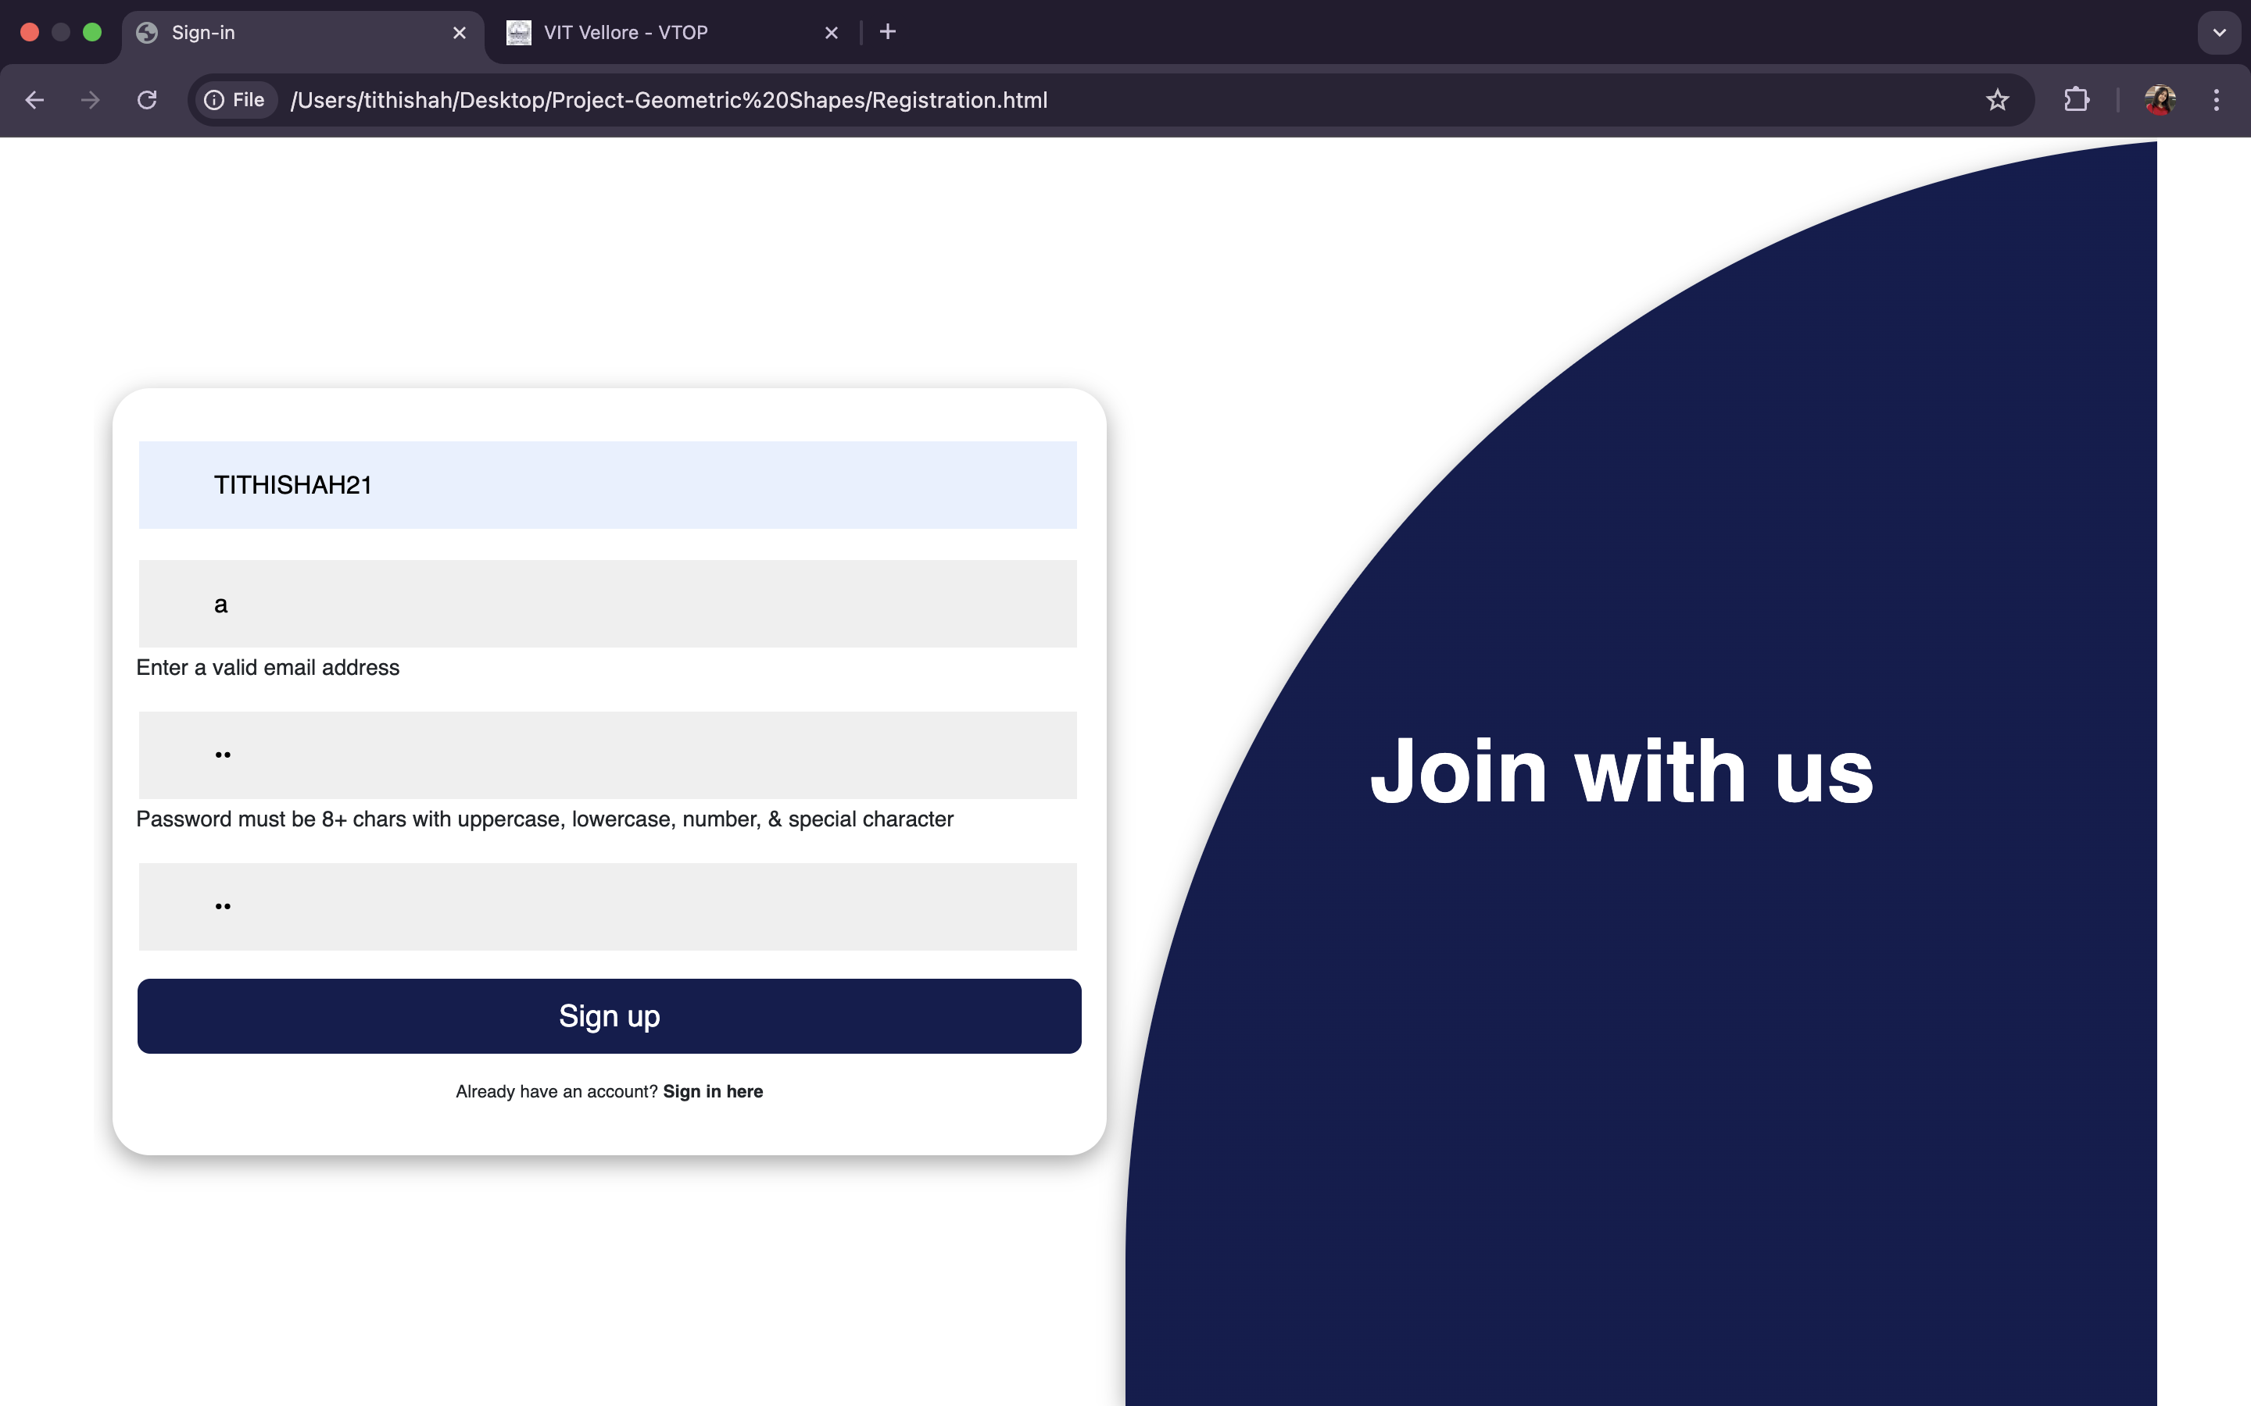

Js code:  
let container = document.getElementById('container')

toggle = () => {

container.classList.toggle('sign-in')

container.classList.toggle('sign-up')

}

setTimeout(() => {

container.classList.add('sign-in')

}, 200)

function validateForm() {

let username = document.getElementById("username").value.trim();

let email = document.getElementById("email").value.trim();

let password = document.getElementById("password").value.trim();

let confirmPassword = document.getElementById("confirm-password").value.trim();

let errorMessages = document.querySelectorAll(".error-message");

errorMessages.forEach(msg => msg.textContent = "");

let isValid = true;

if (username === "") {

setError("username", "Username is required");

isValid = false;

}

let emailRegex = /^[a-zA-Z0-9._%+-]+@[a-zA-Z0-9.-]+\.[a-zA-Z]{2,}$/;

if (!emailRegex.test(email)) {

setError("email", "Enter a valid email address");

isValid = false;

}

let passwordRegex = /^(?=.*[a-z])(?=.*[A-Z])(?=.*\d)(?=.*[@#$%^&+=!]).{8,}$/;

if (!passwordRegex.test(password)) {

setError("password", "Password must be 8+ chars with uppercase, lowercase, number, & special character");

isValid = false;

}

if (password !== confirmPassword) {

setError("confirm-password", "Passwords do not match");

isValid = false;

}

if (isValid) {

alert("Sign up successful! ✅");

}

}

function setError(id, message) {

document.getElementById(id).nextElementSibling.textContent = message;

}

3)Added answers to Course Page practice questions using hover in Js  
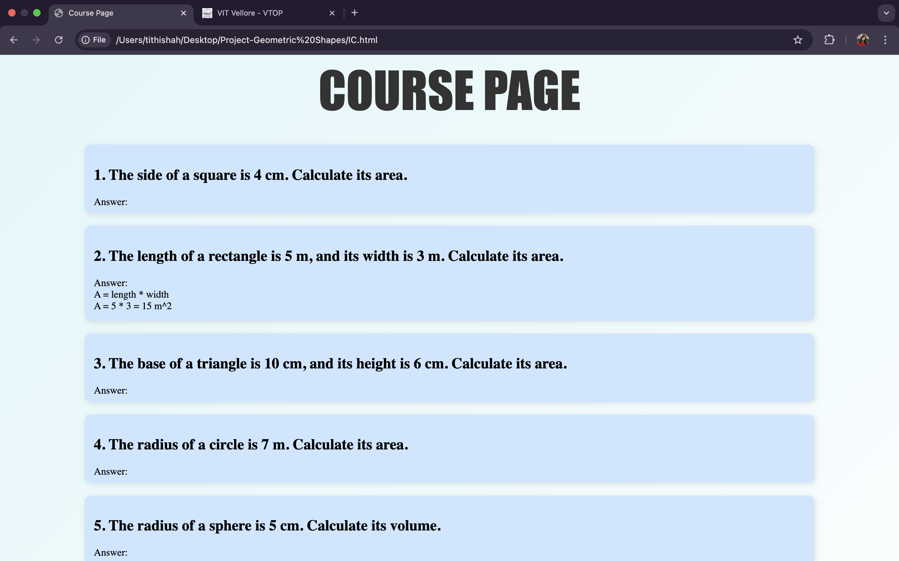

Js Code:

document.addEventListener("DOMContentLoaded", function () {

const cards = document.querySelectorAll(".eg");

cards.forEach((card) => {

card.addEventListener("mouseenter", function () {

this.classList.add("expanded");

});

card.addEventListener("mouseleave", function () {

this.classList.remove("expanded");

});

});

});

1. Added answers to FAQs by clicking them using JS:  
   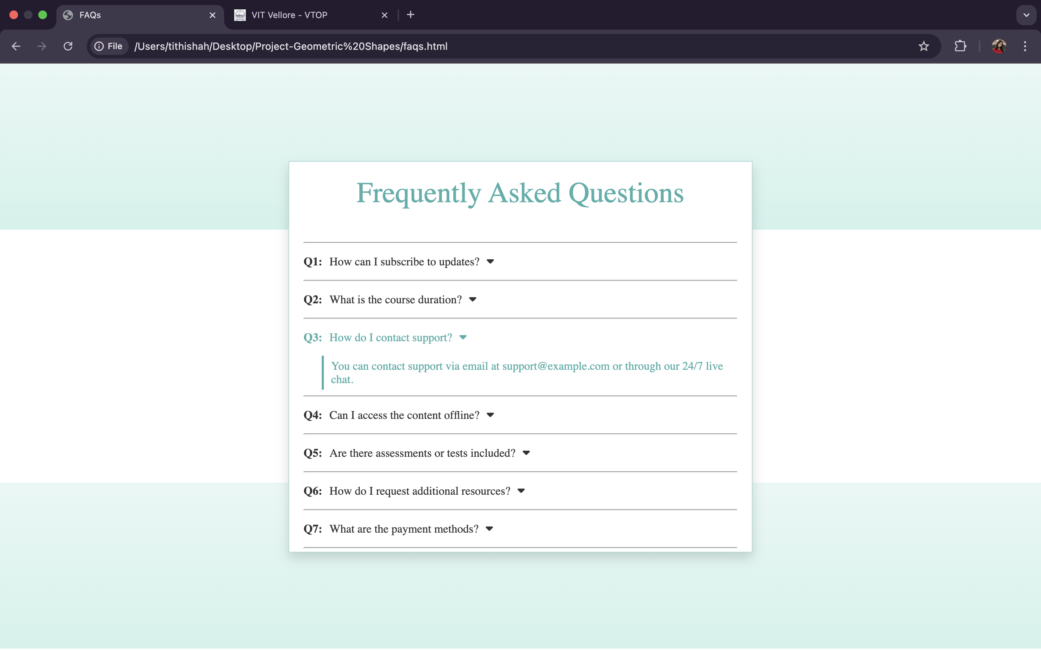

Js code:  
document.addEventListener("DOMContentLoaded", () => {

const faqs = [

{ question: "How can I subscribe to updates?", answer: "You can subscribe to updates by signing up with your email on our homepage." },

{ question: "What is the course duration?", answer: "The course duration varies but typically lasts 6 to 12 weeks, depending on the topic." },

{ question: "How do I contact support?", answer: "You can contact support via email at support@example.com or through our 24/7 live chat." },

{ question: "Can I access the content offline?", answer: "Yes! You can download materials for offline access after enrolling in the course." },

{ question: "Are there assessments or tests included?", answer: "Yes, every course includes quizzes and assessments to track your progress." },

{ question: "How do I request additional resources?", answer: "You can request additional resources through our 'Request Resources' section in the dashboard." },

{ question: "What are the payment methods?", answer: "We accept credit/debit cards, PayPal, and bank transfers for payments." }

];

const questions = document.querySelectorAll(".p");

questions.forEach((question, index) => {

const answerDiv = document.createElement("div");

answerDiv.classList.add("answer");

answerDiv.textContent = faqs[index].answer;

answerDiv.style.display = "none";

question.insertAdjacentElement("afterend", answerDiv);

question.addEventListener("click", () => {

if (answerDiv.style.display === "none") {

answerDiv.style.display = "block";

answerDiv.style.opacity = "0";

setTimeout(() => { answerDiv.style.opacity = "1"; }, 10);

} else {

answerDiv.style.opacity = "0";

setTimeout(() => { answerDiv.style.display = "none"; }, 300);

}

});

});

});

1. Form validation – feedback page using Js  
   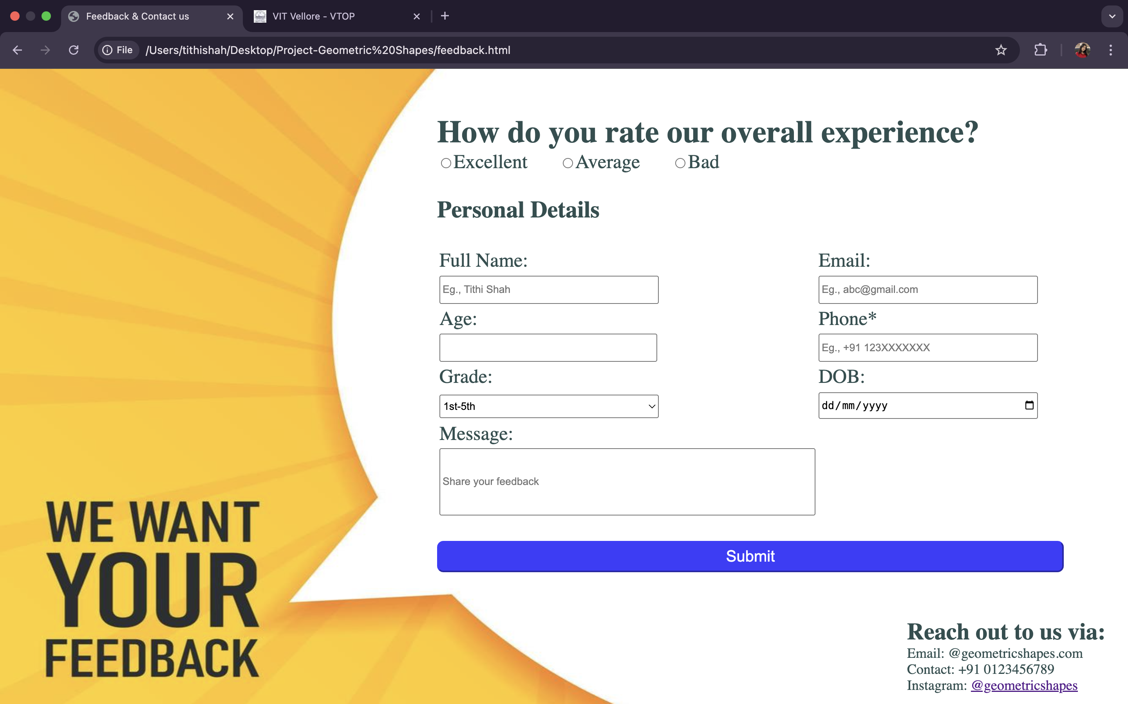

(code similar to register page)  
  
5) Added Js code for MCQs page:  
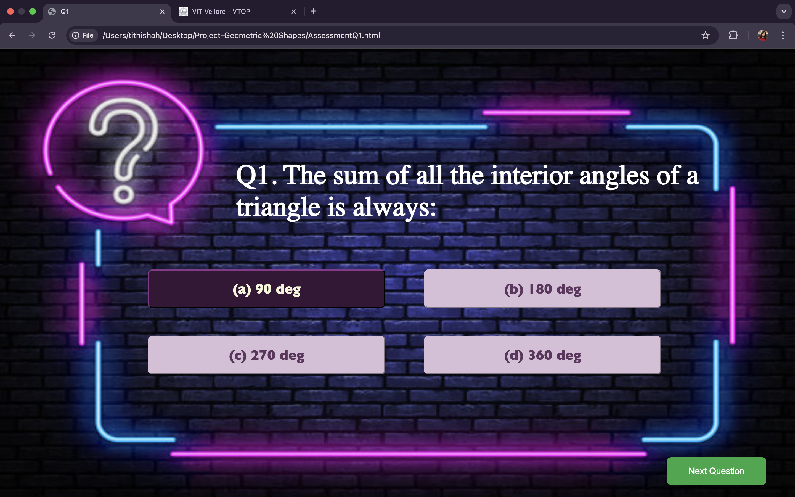

Js code:  
document.addEventListener("DOMContentLoaded", () => {

const options = document.querySelectorAll(".option");

const nextButton = document.getElementById("next-btn");

let selectedOption = null;

const correctAnswer = "b";

options.forEach(option => {

option.addEventListener("click", () => {

if (selectedOption) {

selectedOption.classList.remove("selected");

}

selectedOption = option;

selectedOption.classList.add("selected");

const selectedValue = option.getAttribute("data-value");

if (selectedValue === correctAnswer) {

option.classList.add("correct");

} else {

option.classList.add("wrong");

}

});

});

nextButton.addEventListener("click", () => {

if (!selectedOption) {

alert("Please select an answer before proceeding.");

return;

}

window.location.href = "AssessmentQ2.html";

});

});